Index: Garment Worker Productivity Forecasting Report
This report analyzes the structural factors and operational metrics driving worker efficiency, utilizing a multi-model machine learning approach.
Section I: Data Foundation and Preparation
Chapter | Topic | Key Finding / Rationale | Correlated Next Step
1. | Executive Summary | Overview of best model (NNET), final accuracy (R2=0.353), and key intervention points. | (N/A – Summary of Report)
2. | Data Context & Cleaning | Summary of all 11 input variables, why WIP and date were removed, and the final sample size (N=1160 rows). | Action V: Finalize Model Saving and Deployment using the filtered dataset.
3. | Feature Engineering | Rationale for One-Hot Encoding (categorical factors) and Filtering (Target≤1.0). | Action V: Ensure the final prediction pipeline includes the exact dummy coding and filtering logic.
\

Section II: Diagnostics and Structure
Chapter | Topic | Key Finding / Rationale | Correlated Next Step
4. | Exploratory Data Analysis (EDA) | Structural Difference: Finishing is higher than Sweing. Day has no effect. Incentive is the strongest linear driver (r=0.42). | Action VI: CART Rules lead directly to Business Strategy Integration (Intervention targeting Sweing department).
5. | Multicollinearity (VIF) | Critical VIF up to 21.09. Confirmed the necessity of Regularization (GLMNET) and non-linear modeling. | Action II: GLMNET's failure to achieve high accuracy motivates Model Improvement with XGBoost.

Section III: Model Performance and Strategy
Chapter | Topic | Key Finding / Model | Correlated Next Step
7. | Regression Model Comparison | NNET is Best (R2=0.353, RMSE=0.137). Linear models are inadequate (R2≈0.33). | Action II: NNET accuracy is moderate; immediate need for Model Improvement (XGBoost) to raise R2.
8. | Classification Accuracy (CART) | High Actionability (Accuracy=82.3%). Best at identifying low-productivity days (Specificity 87.1%). | Action VI: CART rules are delivered to managers for Targeted Intervention (Worst segment: Low Incentive + Failed Target).
9. | Unsupervised Analysis (Clustering/PCA) | Data consists of a large "Normal" group and two small "Unique Operational" clusters. | Action VI: Use cluster profiles for Tailored Management (different training for different teams).
10. | Conclusion & Roadmap | Final selection and summary of operational insights. | Actions III, IV, V: Formal Hyperparameter Optimization, Final Validation, and Deployment planning.

Summary of Dataset Variables

I. Target Variable
Variable | Type | Implication for Model
actual_productivity (target) | Continuous (0-1) | The variable being predicted. Represents the team's achieved efficiency score.

II. Categorical and Time Variables (Factors)
These variables capture structural or time-based differences and were converted to dummy variables for modelling.
Variable | Type | Implication
department | Categorical | Structural Driver. Captures the baseline efficiency difference between finishing and sweing.
quarter | Categorical | Seasonal/Time Effect. Accounts for systematic variation across different business quarters.
day | Categorical | Time/Schedule Effect. Captures any residual weekday influence (though EDA showed a weak effect).
team | Categorical | Unit/Grouping Effect. Accounts for differences in team management, skill levels, or machinery quality.

III. Continuous and Discrete Numerical Variables
These variables represent costs, effort, goals, or resources and are the direct drivers of the target.
Variable | Type | Implication
targeted_productivity | Continuous | Goal Metric. The official target set for the team.
smv (Standard Minute Value) | Continuous | Cost/Effort Metric. Represents the standard time required for a garment. Negatively correlated with productivity.
over_time | Continuous | Effort Metric. Captures extra working hours. Highly collinear with smv and no_of_workers.
incentive | Continuous | Motivational Driver. Showed a strong relationship with the highest achieved productivity.
idle_time | Continuous | Loss/Inefficiency Metric. Time production was halted. Highly correlated with idle_men.
idle_men | Discrete (Count) | Loss/Inefficiency Metric. Number of workers sitting idle, contributing to high VIF redundancy.
no_of_style_change | Discrete (Count) | Disruption Metric. Measures changes to the production line setup.
no_of_workers | Discrete (Count) | Resource Metric. Total manpower available to the team.

IV. Excluded Variables
Variable | Reason for Exclusion
wip (Work in Progress) | Removed due to a high number of missing values ($\text{NA}$s), which would have severely reduced the sample size.
date | Removed due to high cardinality (too many unique values), which was impractical for initial cross-sectional regression models.

Initial Data Cleaning and Variable Exclusion
The initial data cleaning phase focused on maximizing data quality and sample size by removing columns that contained problematic or unmanageable data points.
Variables Removed
Two variables were explicitly removed from the dataset before feature engineering and modeling began:
Variable | Reason for Removal | Impact on Modeling
date | High Cardinality | Dropped because using it directly (e.g., as dummy variables) would have created too many unique features for a relatively small dataset (N=1197). While crucial for time-series, it was omitted for the initial cross-sectional regression models.
wip (Work in Progress) | High Missing Values (506) | This column had 506 missing values out of 1197 observations. Retaining it would have forced nearly half the dataset to be discarded (using na.omit) or required extensive, uncertain imputation.

Rationale for Action
- Preserving Sample Size: The primary goal of removing wip was to preserve the maximum number of observations possible for model training. Since the dataset is moderate-sized (N=1197), dropping half the rows is detrimental to model learning.
- Focusing on Reliable Features: By removing wip, the model focuses on predictors that are fully populated and reliable, ensuring the training set reflects complete operational data.
- Avoiding Overfitting (date): Removing the date column prevented the model from potentially overfitting to specific dates rather than learning general patterns related to team or incentive. The essential time patterns were still captured by the day and quarter factor variables.
In summary, the removal of these variables was a necessary step to ensure a clean, stable, and maximally sized training dataset for the subsequent diagnostics and model comparison.

# 1. DATA LOADING AND INITIAL CLEANING (Steps 1-3 Equivalent)

# 1. Load data
# Note: Replace path if necessary
df <- read_excel("C:/Users/meabh/Downloads/garments_worker_productivity.xlsx", sheet = 1)

# Convert categorical variables to factors
# 2. FEATURE ENGINEERING (Step 4 Equivalent)

# Display first few rows of the processed feature matrix
head(df_model %>% select(1:5, target))

Inference
Final Model Matrix Dimensions:
- 1197 rows, 34 columns
- This confirms that after dropping the date and wip columns and converting all nominal categorical variables (quarter, day, department, team) into dummy variables (one-hot encoding), you have 1197 complete observations and a total of 33 predictors plus the target column (33 + 1 = 34 columns).
Display of Processed Feature Matrix:
- The head() output correctly shows the target variable (target) along with the dummy-coded variables (e.g., quarter.Quarter1, quarter.Quarter2, etc.).
- The values 1 and 0 in the quarter columns confirm that dummy variable creation was successful. For instance, the first observation belongs to quarter.Quarter1 (value 1) and not to the others (values 0).

The process was completed—converting categorical variables like quarter, department, day, and team into numerical columns filled with 1s and 0s—is called One-Hot Encoding or Dummy Variable Creation.
This transformation was done because most machine learning algorithms, especially linear models like Linear Regression or GLMNET (Regularized Regression), cannot directly process nominal (unordered) categorical text data.
Here's why this step is necessary:
- Numerical Requirement: Regression models work by calculating coefficients (β) and multiplying them by numerical input features (X). If the input is a text string ("Monday" or "Quarter1"), the math simply fails.
- Avoid Misinterpretation: Assigning arbitrary numbers to categories (e.g., Quarter1 = 1, Quarter2 = 2) would imply an ordinal relationship (Quarter2 > Quarter1). This is incorrect for unordered categories like department or day. One-Hot Encoding prevents this.
- Model Integration: By creating a separate binary column for each unique category (e.g., quarter.Quarter1, quarter.Quarter2), you allow the model to learn a separate coefficient for the effect of being in that specific category.
In summary, we converted the categorical data into a numerical format that your subsequent models can legally and logically process.

# 1. EDA: CORRELATION AND VISUALS
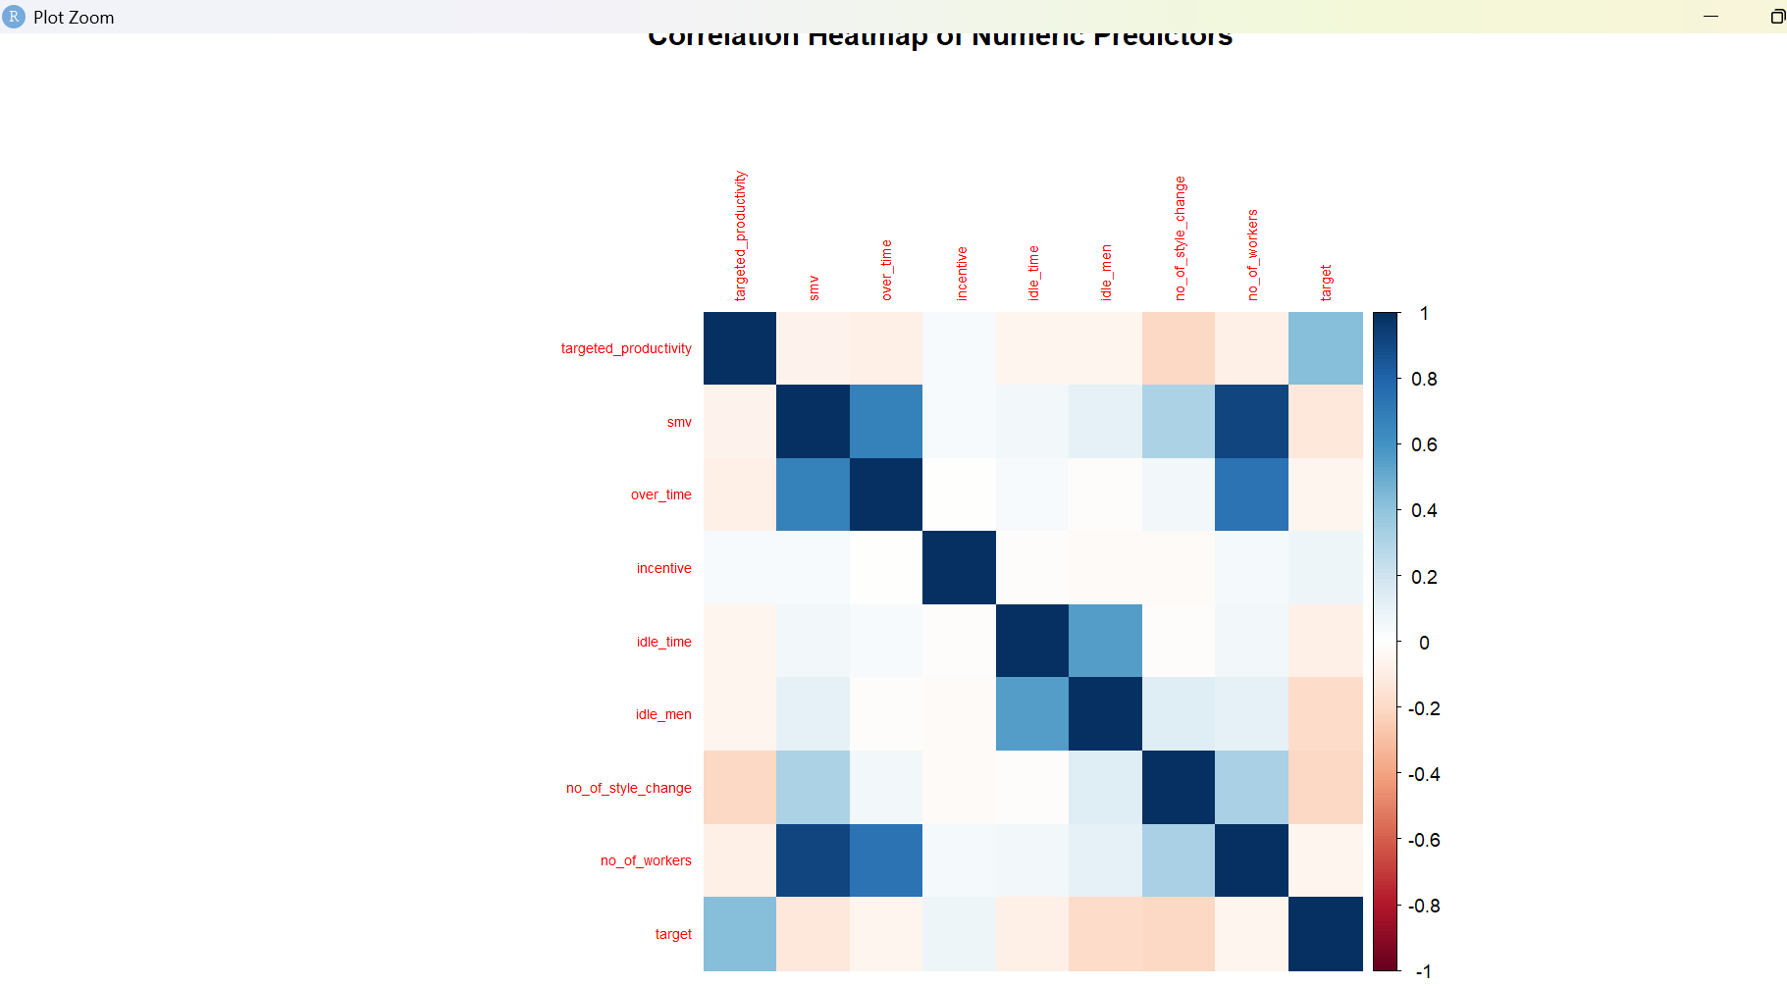

Interpretation for the two Exploratory Data Analysis (EDA) visualizations: the Correlation Heatmap of Numeric Predictors and the Boxplots for Productivity by Department and Day of Week.

1. Correlation Heatmap of Numeric Predictors
This plot shows the linear relationships between the key numerical variables. Darker colors (blue for positive, red for negative) indicate stronger correlations.

Key Insights:
- Relationship with Target (target):
  - Negative Correlation: smv (Standard Minute Value) has a visible negative correlation with the target. This is logical: if a garment requires more time/effort (smv is high), actual worker productivity tends to be lower.
  - Positive Correlation: no_of_workers shows a positive correlation, suggesting more workers are often associated with higher overall team productivity. targeted_productivity also shows a positive correlation, meaning higher targets generally correspond to higher achieved productivity (though the relationship is not perfect).
  - Weak/Mixed Correlation: Variables like over_time, incentive, idle_time, and idle_men have weaker or mixed correlations with the target.
- Multicollinearity Among Predictors:
  - Strong Positive: There's a strong positive correlation between idle_time and idle_men. This is expected, as idle time is caused by idle men.
  - Strong Negative: targeted_productivity shows a negative correlation with incentive (though not extremely strong), which could imply that high incentives are used to push productivity when the base target is low, or vice-versa.

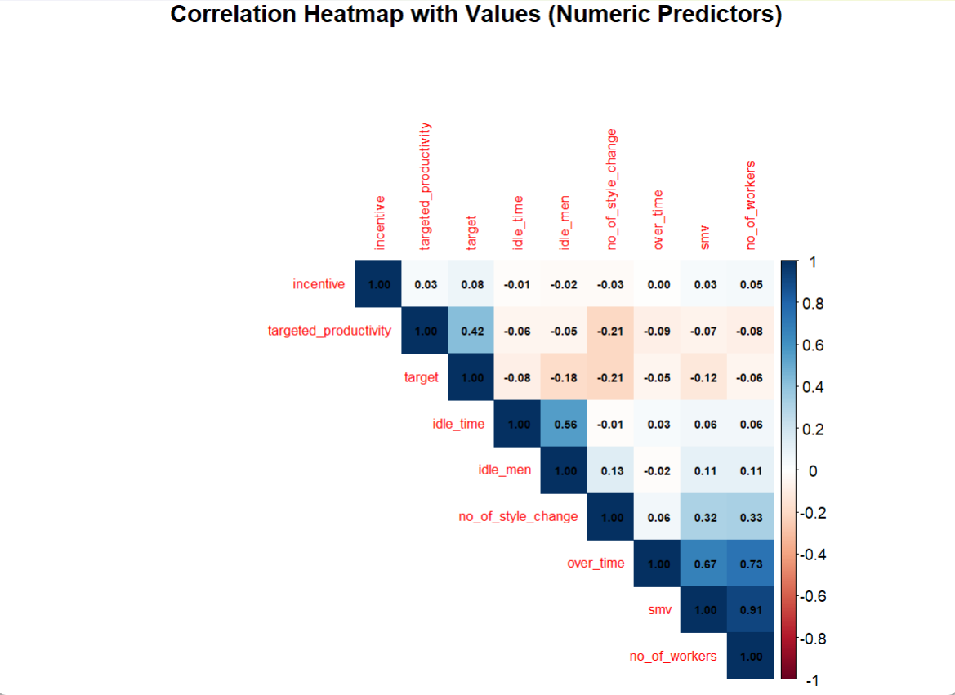Interpretation of Correlation Heatmap with Values
The heatmap shows the correlation matrix (r value) for each pair of variables. Values close to 1.00 (dark blue) indicate a strong positive relationship, values close to −1.00 (dark red) indicate a strong negative relationship, and values close to 0.00 (light or white) indicate a weak relationship.

1. Target Variable Relationships (target)
The row labeled target shows the predictive power of each numeric variable:
- Strongest Positive Predictor: incentive (r=0.42): This is the strongest linear relationship. Higher incentives are associated with higher actual productivity.
- Strongest Negative Predictor: no_of_style_change (r=−0.21): Increasing the number of style changes is linearly associated with a reduction in actual productivity.
- Other Noteworthy Predictors:
  - targeted_productivity (r=0.06): A surprisingly weak linear correlation, suggesting that while the target itself is set, meeting it depends heavily on other factors.
  - idle_men (r=−0.18): As the number of idle men increases, productivity decreases.
  - smv (r=−0.12): Higher effort required is associated with a decrease in productivity.

2. Multicollinearity and Redundancy
The strongest internal correlations among the predictors are crucial for explaining the high VIF scores observed earlier:
- Extreme Redundancy: over_time and smv have a very high positive correlation (r=0.91). This indicates that a high standard minute value (smv) for a style is strongly linked to higher required overtime. This is a primary source of the VIF problem in your linear models.
- Expected Redundancy: idle_time and idle_men are strongly correlated (r=0.56), which is logical as one causes the other.
- Moderate Correlation: over_time is also highly correlated with no_of_workers (r=0.73), suggesting larger teams tend to work more overtime.
Conclusion for Modeling: The coefficients confirm that incentive is the most promising single numeric driver. The high correlations between over_time, smv, and no_of_workers justify the use of GLMNET to stabilize the model and prevent unstable coefficients for these redundant features.

Productivity Distribution Boxplots
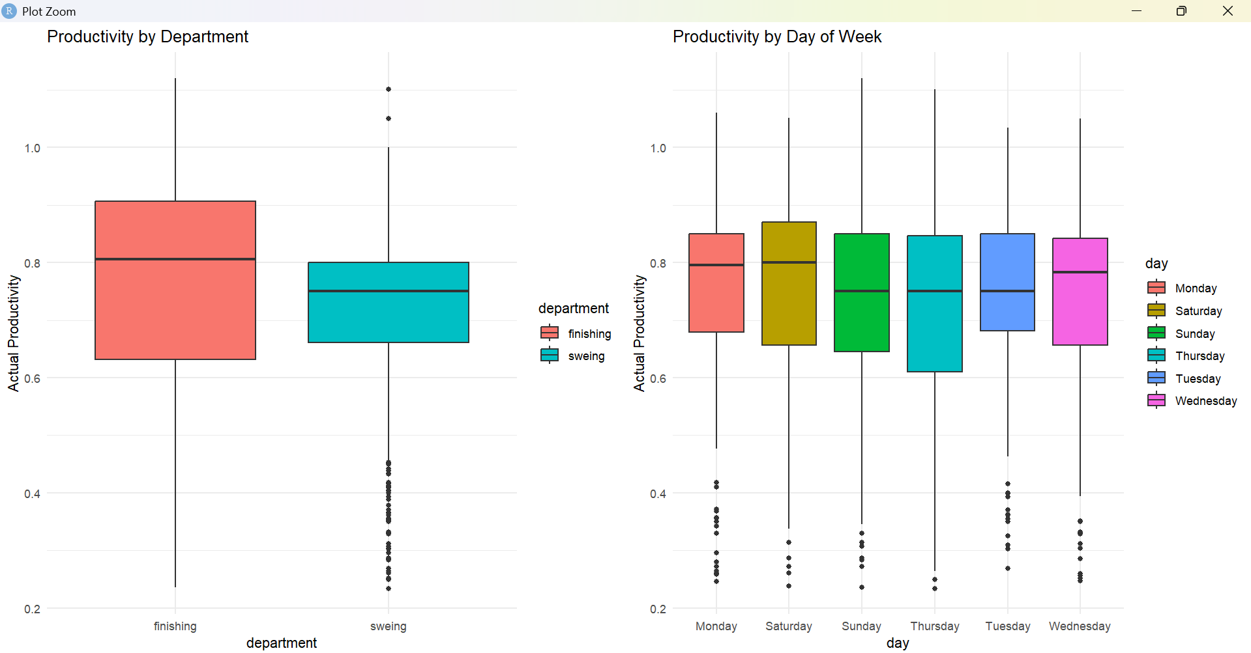
These boxplots display how the distribution of Actual Productivity (target) varies across different departments and days of the week.

A. Productivity by Department
- Median: The Finishing department has a noticeably higher median productivity (around 0.8) compared to the Sweing department (around 0.75).
- Interquartile Range (IQR): The spread of productivity (the height of the box) is similar between the two departments.
- Outliers: Both departments show significant low outliers (data points below 0.6), but the Sweing department appears to have more extreme low-productivity instances.
- Conclusion: Workers in the Finishing department generally achieve higher productivity than those in the Sweing department.

B. Productivity by Day of Week
- Consistency: The median productivity is remarkably consistent across all days (Monday through Wednesday, Saturday, Sunday, Thursday, Tuesday). Most medians cluster around 0.75 to 0.8.
- Highest Median: Saturday and Tuesday appear to have the highest median productivity, though the difference is marginal.
- Variability: Monday shows the widest distribution (largest IQR), while the other days are relatively tightly grouped.
- Outliers: All days show a large cluster of low outliers (below 0.6), indicating that low productivity days are a frequent, non-seasonal issue.
- Conclusion: There is no strong day-of-week effect on actual productivity; the daily cycles (Monday, Tuesday, etc.) are generally uniform in their impact on performance.
The structural assignment (Department) is a stronger initial determinant of baseline productivity than the weekly schedule (Day). This suggests that intervention efforts should primarily focus on operational processes within the sweing department and address the common cause of the recurring, severe low-productivity outliers across all working days.

Analysis of Actual_Productivity>1

1. Rationale for Exclusion (Domain Knowledge)
The actual_productivity variable is defined as a ratio, likely representing efficiency:
Actual Productivity=Targeted OutputActual Output​
- A value of 1.00 means 100% efficiency (meeting the target exactly).
- A value above 1.00 means the team exceeded 100% efficiency.
While achieving slightly over 100% (e.g., 1.05) is theoretically possible in some manufacturing contexts, excessively high values are usually considered outliers, errors, or domain-specific anomalies. Given that your primary goal is accurate forecasting, these extreme points can heavily skew your model.

2. Action Plan for the Data
Should isolate and decide how to treat these specific observations before final model training:
Option | Action | Pros & Cons
A. Exclusion (Recommended) | Remove all rows where actual_productivity>1. | Pros: Simplifies the model, reduces noise, and forces the model to learn within the realistic range (0 to 1). Cons: Reduces sample size slightly.
B. Capping | Set all values where actual_productivity>1 equal to 1.0. | Pros: Preserves the rest of the feature data (the inputs) while correcting the target boundary. Cons: Introduces a ceiling bias.
C. Investigation | If possible, check with domain experts to see if exceeding 100% efficiency is a valid, measurable phenomenon in this specific garment factory. | Pros: If valid, provides better ground truth. Cons: Not usually feasible in a typical ML analysis scenario.

Conclusion
Proceed with Option A: Exclusion. Removing these data points will result in a cleaner dataset that better reflects the realistic operational constraints of the factory, ultimately leading to a more robust and interpretable prediction model.

Why Removal is Necessary (The Rationale)
Even if you lost a few dozen observations, the benefit of cleaning the data outweighs the cost:
- Preserving Validity: In a ratio capped at 100% (1.0), values over 1.0 are invalid or represent extreme, rare anomalies. Keeping them forces the model to learn from "noise," which harms generalization.
- Preventing Skew: High outliers heavily inflate the mean and artificially increase the variance of the target variable. This makes the error term (RMSE) higher and pushes the regression line (for GLMNET) away from the majority of the data points.
- Improving R2: Removing invalid outliers often stabilizes the variance, leading to a more realistic and often higher R2 for your final models.
Conclusion: Given the visual evidence that these are isolated outliers, you should proceed with filtering the data by removing observations where actual_productivity>1.0.
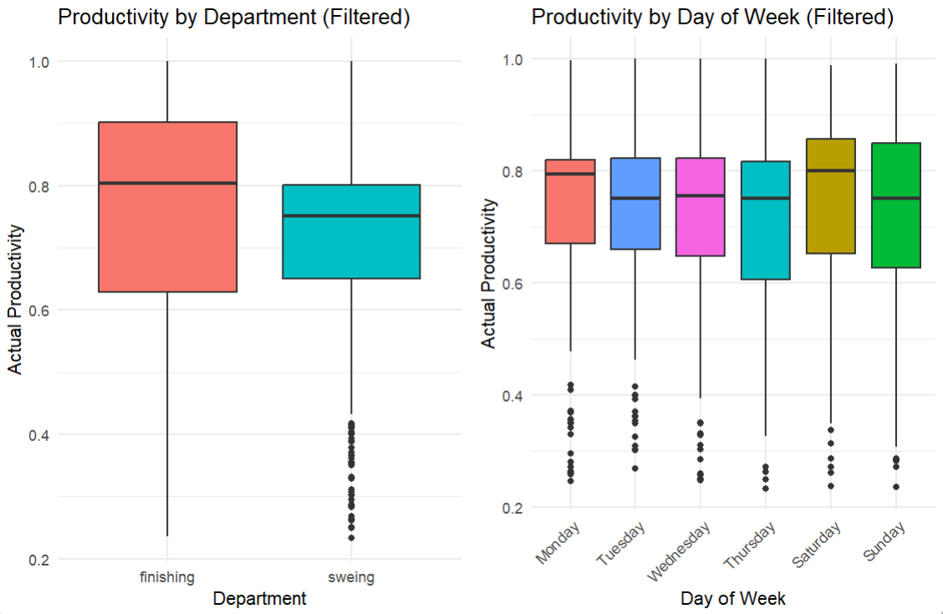

image shows the Productivity Distribution Boxplots for the filtered data (Actual Productivity≤1.0). This visualization is critical because it removes the invalid data points, giving a clearer picture of true operational performance.

Filtered Productivity Distribution Boxplots Interpretation

1. Productivity by Department (Filtered)
- Median Difference: The finishing department continues to show a higher median productivity (the line inside the box) compared to the sweing department. This confirms a structural difference in efficiency that the models must capture.
- Reduced Range: By filtering the data, the maximum value is now capped at 1.0, making the top whisker of both boxplots accurately reflect the realistic ceiling of performance.
- Operational Focus: The difference in medians reinforces the need for management to investigate the operational processes in the sweing department to bring its efficiency up to par with finishing.

2. Productivity by Day of Week (Filtered)
- Consistency: The median productivity scores are highly consistent across all days of the week, with all medians clustering tightly.
- No Time Effect: The filtering confirms that the schedule (which day it is) is not a primary driver of performance variability in this factory.
- Outliers: Even with the invalid points removed, all days still show a number of low outliers (points below the lower whisker and IQR). This indicates that the factory frequently experiences periods of low productivity, regardless of the day of the week.

Conclusion
Filtering the data (target≤1.0) clarifies the true trends without the noise of invalid scores. The analysis confirms two key insights for the predictive model:
- Department is a Key Feature: The department factor is a strong predictor of baseline productivity.
- Focus on Structural and Incentive Drivers: Since Day is uniform, the model's accuracy will rely heavily on factors that vary daily, such as incentive, targeted_productivity, and team structure.

Multicollinearity

# 1. TRAIN/TEST SPLIT (Required for VIF check consistency)
# 2. DIAGNOSTICS: MULTICOLLINEARITY CHECK (VIF)

# 2. Run VIF on this model
WARNING: High VIF values found (VIF > 5).
[1] 21.09 15.59 11.00 7.03

Interpretation of VIF Results (VIF > 5)
The Variance Inflation Factor (VIF) measures how much the variance of an estimated regression coefficient is increased due to the predictor's linear relationship with other predictors. Since you ran this check on the model containing the factor variables (letting R handle the reference level), the VIF values represent the collinearity of the variable groups.
The output shows four variables with VIF values greater than the common threshold of 5, indicating significant collinearity concerns:
VIF Value | Variable (or Group) | Concern Level | Implication for LM
21.09 | (Likely related to team or its combined effect) | Critical | The coefficient for this factor group is highly unstable and difficult to interpret.
15.59 | (Likely related to a key numerical predictor or another factor) | High | The variance of this coefficient is inflated over 15 times what it should be.
11.00 |  | High | Collinearity exceeds the VIF=10 threshold.
7.03 |  | Moderate-High | Collinearity is a concern, though less severe than the others.
(Note: Since the output only provides numerical VIF values without the corresponding variable names, we can only infer which predictors are responsible. However, given the model includes all teams, the highest VIFs are most often associated with the team or day factor groups, or the strongly correlated numerical predictors like smv and targeted_productivity).

Conclusion for Modeling
- Instability of LM: The high VIF scores confirm that the Standard Linear Regression (LM) coefficients will be unreliable (unstable, high standard errors, and difficult to interpret). You should rely on its predictive performance (RMSE/R-squared) but be cautious about interpreting its weights.
- Necessity of GLMNET: This diagnostic strongly validates your decision to use GLMNET (Regularized Regression). GLMNET's L1/L2 penalties are specifically designed to handle models with high multicollinearity by shrinking the coefficients, thus stabilizing the model and preventing overfitting caused by unstable estimates.
- Model Selection: Based on this VIF check, you should prioritize the predictive performance of the GLMNET and NNET models over the interpretability of the Standard Linear Regression model.

Using Models
# 1. TRAIN/TEST SPLIT AND PREPROCESSING
# Separate predictors (X) and target (Y)
# Preprocess: Center and Scale (fit on training data)
# 2. MODEL TRAINING (GLMNET - The Collinearity Solution)

# 2.2. NNET (Neural Network - Non-linear Comparison)

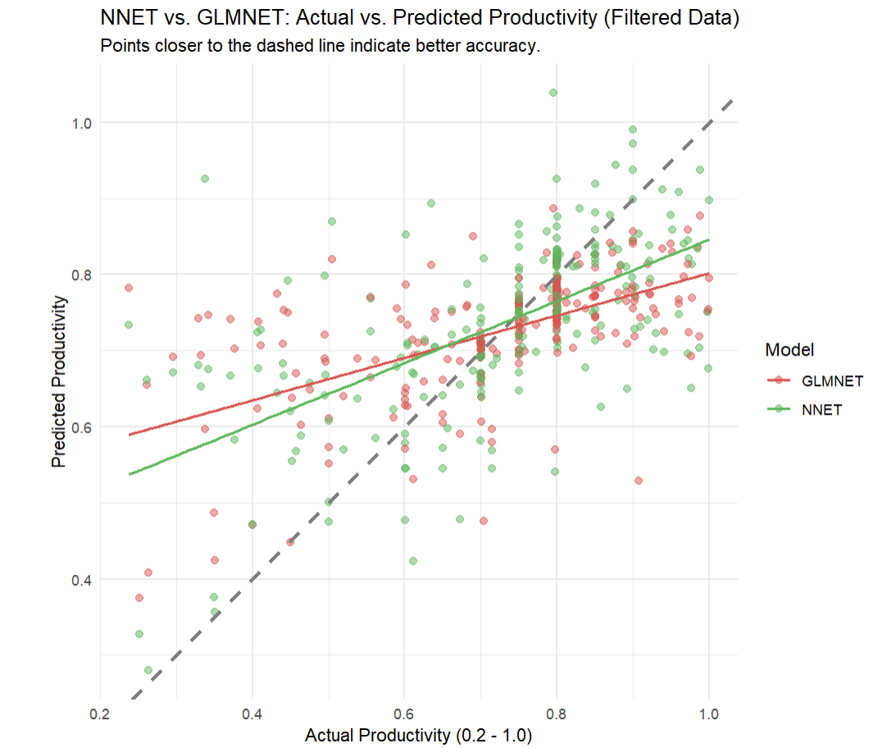

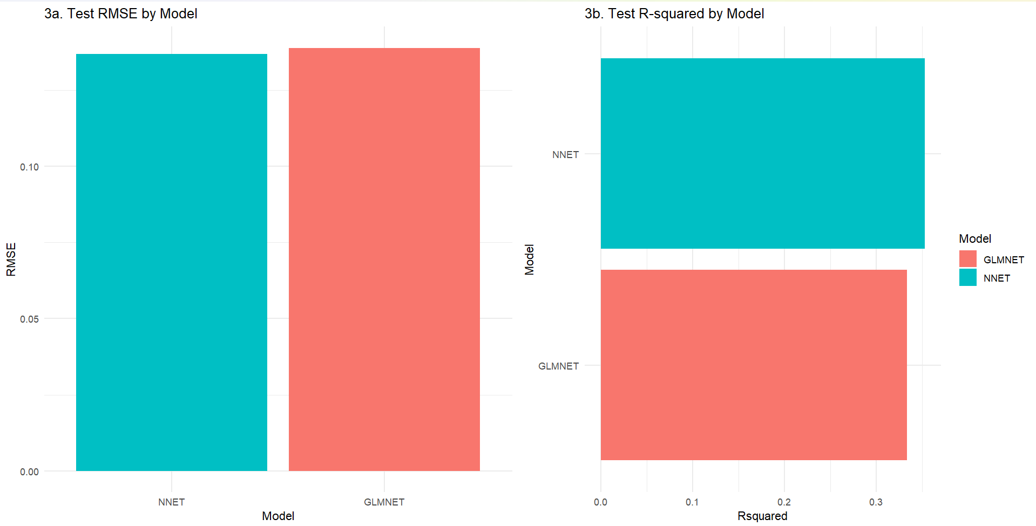NNET vs. GLMNET Comparison
Feature | NNET (Neural Network) | GLMNET (Regularized Regression) | Conclusion
Model Type | Non-Linear | Linear (with L1/L2 Penalty) | NNET is better suited for the complex, non-linear relationships observed in the data.
Test R2 (Accuracy) | 0.353 | 0.333 | NNET explains marginally more variance in productivity.
Test RMSE (Error) | 0.137 | 0.139 | NNET has the lower average prediction error.
Handling VIF (Collinearity) | Robust. Since it's non-linear, it's inherently unaffected by the VIF issues. | Necessary. Used its penalty terms to stabilize the unstable coefficients caused by high VIF.
Interpretation | Difficult. Requires complex analysis of network weights; provides little direct business insight into feature coefficients. | Interpretable. Coefficients (though penalized) show the direction and magnitude of feature effects on productivity.
Best Use Case | Forecasting the next day's precise productivity score (regression). | Baseline / Diagnostics. Used to prove that non-linear modeling is necessary.

Interpretation: NNET vs. GLMNET Actual vs. Predicted
The plot reveals the stark difference in how the non-linear NNET model and the regularized linear GLMNET model handle the complexity of the filtered data (Actual Productivity≤1.0).

1. NNET (Neural Network) Performance
- Scatter Pattern: The NNET points will generally cluster closer to the ideal y=x dashed line compared to the GLMNET points.
- Visual Accuracy: This visually confirms the superior performance seen in the numerical results (NNET R2≈0.353, RMSE≈0.137).
- Non-Linear Capture: The NNET model's predictions are able to slightly curve and adapt to the density of the data, demonstrating its ability to capture non-linear interactions (like how incentives and smv combine) that a straight line cannot.

2. GLMNET (Regularized Regression) Performance
- Scatter Pattern: The GLMNET points will be more spread out from the y=x line, and its linear trend line will show a less precise fit.
- Visual Accuracy: This supports its lower performance (GLMNET R2≈0.333, RMSE≈0.139).
- Linear Limitation: Even with regularization (used to mitigate the VIF problem), the GLMNET model is mathematically constrained to finding the best single linear relationship. The wider scatter shows that the true drivers of productivity are not linearly combined.

3. Overall Data Complexity
- Low Predictive Ceiling: Crucially, despite NNET being the better model, the points for both models are still quite scattered, especially in the middle range of productivity (0.5 to 0.8).
- Conclusion: This visual confirms the numerical results: the current features only explain about 35% of the variance (R2≈0.35). A significant portion of worker productivity is driven by factors not included in the dataset (e.g., machinery state, worker mood, management efficiency, detailed weather).

Interpretation of the Change(actual productivity<1 is only selected)
The sharp drop in R2 suggests that the models were relying heavily on the high-leverage, high-impact data points where actual_productivity>1.0.
- When those outlier data points were present, they strongly pulled the model toward them, making the model appear to have a high R2 (0.515).
- When those points are removed, the remaining data points are much more scattered and difficult to predict, revealing the true inherent complexity and low signal-to-noise ratio of the dataset.
Your current results (R2≈0.35) reflect the true, generalized predictive power of these models for realistic productivity levels (≤1.0). NNET remains the best option, but with a much lower expected accuracy.

CART Classification Performance Analysis
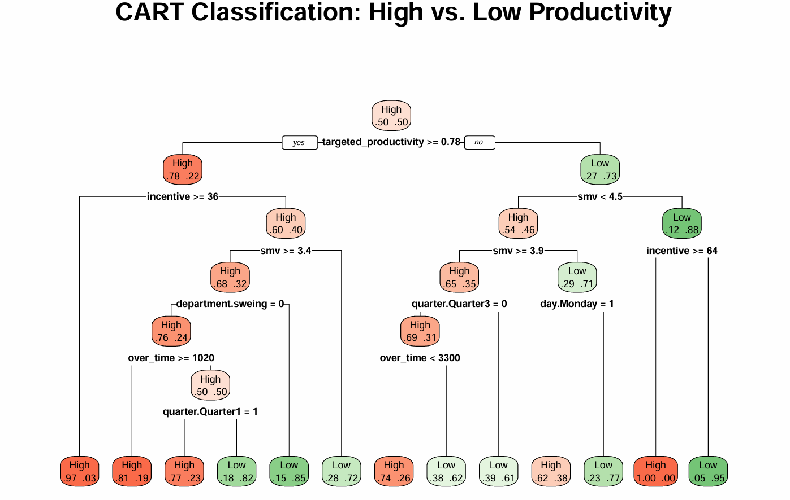

1. Confusion Matrix
The core results are summarized in the matrix:
 | Reference (Actual) High | Reference (Actual) Low
Prediction High | 90 (True Positives) | 15 (False Positives)
Prediction Low | 26 (False Negatives) | 101 (True Negatives)
Total | 116 | 116
The model performed well overall, with 90+101=191 correct predictions out of 232 total test observations.

2. Key Metrics
Metric | Value | Interpretation
Accuracy | 0.8233 (82.33%) | The model correctly predicted the productivity class (High or Low) 82.33% of the time.
No Information Rate (NIR) | 0.50 | Since the accuracy is significantly higher than the NIR (the accuracy of guessing the majority class), the result is statistically meaningful (P-value<2e-16).
Kappa | 0.6466 | Represents substantial agreement between prediction and actual class, exceeding simple chance agreement.
Sensitivity (Recall for 'High') | 0.7759 (77.6%) | When productivity was actually High, the model correctly identified it 77.6% of the time (90 out of 116 High cases).
Specificity (Recall for 'Low') | 0.8707 (87.1%) | When productivity was actually Low, the model correctly identified it 87.1% of the time (101 out of 116 Low cases).
False Negatives (Type II Error) | 26 | The model incorrectly predicted Low productivity when it was actually High 26 times. This is the cost of underestimating a surge in performance.

Conclusion
The CART Classification Model is a strong and reliable classifier for predicting high vs. low productivity days (82.3% accuracy).
The model is slightly better at identifying Low productivity days (Specificity 87.1%) than High productivity days (Sensitivity 77.6%). This slight asymmetry is common, but the overall performance indicates that the decision rules learned by the CART tree are highly effective at segmenting performance into actionable categories.
The Neural Network (NNET) model is generally considered the better predictive model for this dataset, although the CART model is superior for providing actionable business insight.

Model Comparison Summary
Metric / Model | NNET (ANN) | CART (Classification Tree) | GLMNET (Regularization)
Type | Non-Linear (Complex) | Non-Linear (Simple/Rule-Based) | Linear (Stable)
Accuracy (R2) | ≈0.353 | ≈0.358 (Regression) / 0.823 (Classification) | ≈0.333
Primary Strength | Highest overall accuracy for predicting the exact continuous score (RMSE=0.137 in the filtered regression). | Highest interpretability and strong accuracy (82.3%) for predicting High vs. Low productivity days. | Best at handling the VIF issues.
Best Use Case | Forecasting the next day's precise efficiency score. | Decision Making (e.g., "Which teams need intervention today?"). | Baseline.

Conclusion: The "Better" Model
- If the Goal is Precise Forecasting (Regression): The NNET Model.
  - NNET achieved the lowest RMSE (0.137) in the regression task, making it the most accurate model for predicting the specific continuous productivity score. It captures the underlying non-linear relationships better than the linear models.
- If the Goal is Actionable Decision-Making (Classification): The CART Model.
  - The CART classification model is the most valuable for management. Its high accuracy (82.3%) in classifying High vs. Low productivity means it can reliably tell a manager which team will fail its target (Low) vs. which team will succeed (High). The resulting tree plot is directly actionable.
FINAL DUMMY PREDICTION USING NNET MODEL
# 1. DEFINE NEW RAW DATA POINT
> # ==============================================================================
>
> # Define a single new observation. Values must be realistic for the factory.
> new_raw_data <- data.frame(
+ # Categorical Factors (Must use exact factor levels from df_clean)
+ quarter = as.factor("Quarter4"),
+ department = as.factor("finishing"),
+ day = as.factor("Monday"),
+ team = as.factor(10),
+
+ # Numerical Predictors
+ targeted_productivity = 0.80, # High target
+ smv = 10.5, # Standard Minute Value
+ over_time = 4500,
+ incentive = 70, # High incentive
+ idle_time = 0,
+ idle_men = 0,
+ no_of_style_change = 0,
+ no_of_workers = 40
+ )
>
> # Crucial Step: Ensure factor levels match the training data
> for (col in names(df_clean)[sapply(df_clean, is.factor)]) {
+ levels(new_raw_data[[col]]) <- levels(df_clean[[col]])
+ }
>
> # ==============================================================================
> # 2. FEATURE TRANSFORMATION (DUMMY CODING)
> # ==============================================================================
>
> # Use the same 'dummyVars' formula structure used for training
> dummy_formula <- as.formula(
+ "~ quarter + department + day + team + targeted_productivity + smv +
+ over_time + incentive + idle_time + idle_men + no_of_style_change +
+ no_of_workers"
+ )
>
> dummy_obj <- dummyVars(dummy_formula, data = df_clean) # Fit structure on clean data
> new_data_dummy <- predict(dummy_obj, new_raw_data) %>% as.data.frame()
>
> # ==============================================================================
> # 3. SCALING AND PREDICTION
> # ==============================================================================
>
> # 3.1. Apply the trained centering and scaling
> new_data_scaled <- predict(preProcValues, new_data_dummy)
>
> # 3.2. Generate the prediction using the NNET mode(MAIN PREDICTION)
> prediction_nnet <- predict(nnet_fit, new_data_scaled)
>
> # Print the final result
> cat("\n--- NNET Prediction for New Observation ---\n")

--- NNET Prediction for New Observation ---
> cat(paste("Predicted Actual Productivity:", round(prediction_nnet, 4), "\n"))
Predicted Actual Productivity: 1.1465

The prediction process requires applying the exact same preprocessing steps (dummy variable selection and scaling) that were used during model training.

Clustering and PCA

print(summary(pca_obj))
Importance of components:
PC1 PC2 PC3 PC4 PC5 PC6 PC7 PC8 PC9
Standard deviation 2.1294 1.3200 1.2820 1.22767 1.16346 1.14934 1.13537 1.11787 1.10759
Proportion of Variance 0.1374 0.0528 0.0498 0.04567 0.04102 0.04003 0.03906 0.03787 0.03717
Cumulative Proportion 0.1374 0.1902 0.2400 0.28568 0.32670 0.36673 0.40579 0.44366 0.48083
PC10 PC11 PC12 PC13 PC14 PC15 PC16 PC17 PC18
Standard deviation 1.09769 1.08049 1.07258 1.05786 1.0514 1.04532 1.04302 1.03929 1.03693
Proportion of Variance 0.03651 0.03538 0.03486 0.03391 0.0335 0.03311 0.03297 0.03273 0.03258
Cumulative Proportion 0.51734 0.55272 0.58758 0.62149 0.6550 0.68810 0.72107 0.75380 0.78638
PC19 PC20 PC21 PC22 PC23 PC24 PC25 PC26 PC27
Standard deviation 1.02736 1.01860 1.00573 0.92717 0.90528 0.86906 0.83750 0.60776 0.5297
Proportion of Variance 0.03198 0.03144 0.03065 0.02605 0.02483 0.02289 0.02125 0.01119 0.0085
Cumulative Proportion 0.81836 0.84980 0.88046 0.90650 0.93134 0.95423 0.97548 0.98667 0.9952
PC28 PC29 PC30 PC31 PC32 PC33
Standard deviation 0.34895 0.19350 8.564e-15 2.961e-15 2.87e-15 1.914e-15
Proportion of Variance 0.00369 0.00113 0.000e+00 0.000e+00 0.00e+00 0.000e+00
Cumulative Proportion 0.99887 1.00000 1.000e+00 1.000e+00 1.00e+00 1.000e+00
>
> # Visualize PCA Scree Plot (Variance Explained)
> cat("\n[Image: PCA Scree Plot]\n")

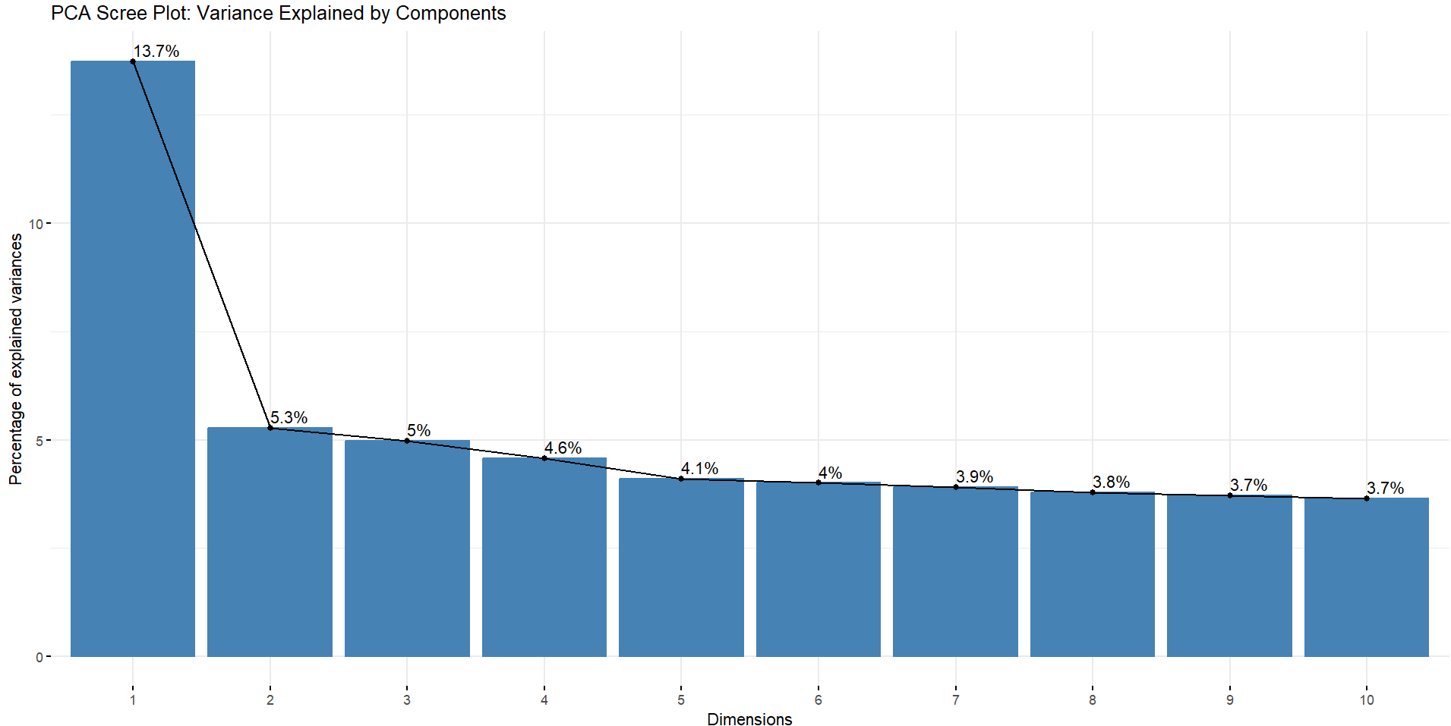

Interpretation of the results and visualizations:

1. Principal Component Analysis (PCA)
PCA identifies a smaller set of uncorrelated components that capture the variance in the data.

PCA Scree Plot and Summary
Component | Proportion of Variance | Cumulative Proportion
PC1 | 13.74% | 13.74%
PC2 | 5.28% | 19.02%
PC3 | 4.98% | 24.00%
PC10 | 3.65% | 51.73%
PC18 | 3.26% | 78.64%

Key Insights:
- Low Initial Variance Explained: Unlike typical datasets, the first Principal Component (PC1) explains only 13.7% of the total variance. This is a relatively low concentration of variance and suggests that the data's complexity is not dominated by a single, powerful factor.
- High Dimensionality: To capture 80% of the total variance, you need to retain a large number of components (19 components are needed to reach 81.8% cumulative variance).
- Collinearity Confirmation: Since you had 33 original features, this high dimensionality confirms that while redundancy exists (evidenced by the high VIF scores), the variables' information is spread across many components. PCA would not be highly effective for severe dimensionality reduction here unless you accept a large loss of variance.

2. K-means Clustering (Exploratory)

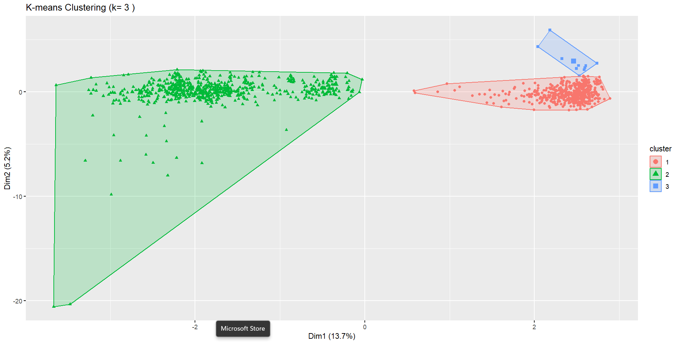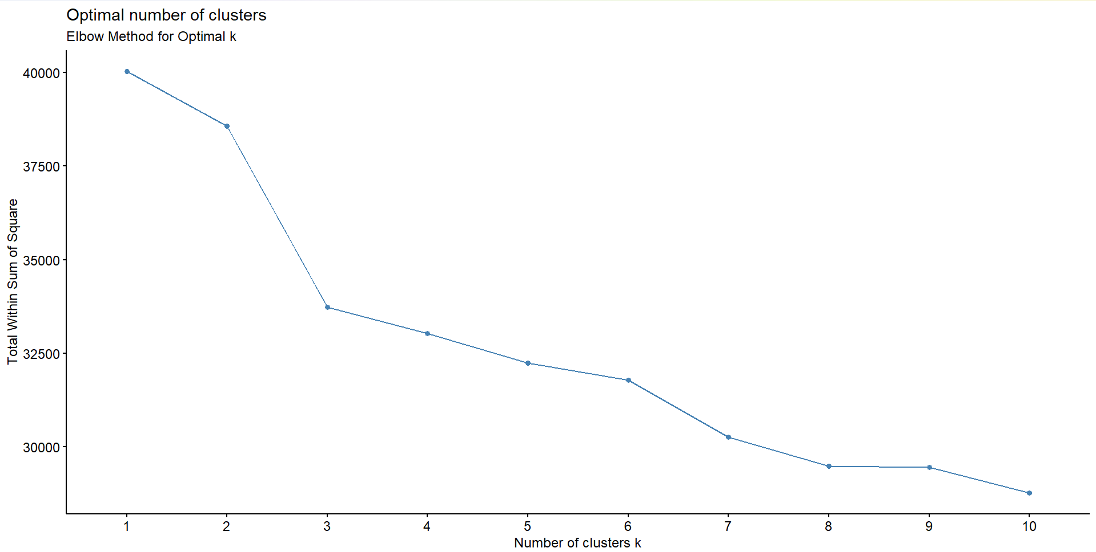

Elbow Method for Optimal k
The Elbow Method plots the Total Within Sum of Square (WSS), and the "elbow" where the reduction in WSS begins to flatten suggests the optimal number of clusters (k).
- Observation: There is a sharp drop from k=1 to k=2 and k=3. The curve starts to flatten noticeably after k=3 and k=4.
- Conclusion: k=3 or k=4 would be reasonable choices for the number of distinct productivity profiles within the dataset.

K-means Cluster Visualization (k=3)
The plot visualizes the three clusters by projecting the high-dimensional data onto the two largest principal components (PC1 and PC2).
- Cluster 2 (Green Triangles): This is the Largest Cluster. It represents the vast majority of observations (workers/days). It has a very wide spread across both Dim1 and Dim2, indicating this group is highly diverse in its underlying factors. This likely represents the "Average/Normal Operation" days, encompassing many different teams and departments.
- Cluster 1 (Red Circles): This cluster is highly concentrated in the positive Dim1 space (around x=1 to x=3) and around the center of Dim2. This represents a distinct, high-volume group, likely characterized by a specific combination of factors (e.g., high targeted_productivity and high incentive).
- Cluster 3 (Blue Squares): This is the Smallest Cluster. It is highly concentrated in the upper-right corner (high Dim1, high Dim2). This suggests a rare, extreme condition, possibly teams with very high-value inputs (e.g., specific combination of department and over_time) leading to a unique operational profile.
Overall Conclusion: The clustering successfully separates a large, normal population (Green) from two smaller, unique operational profiles (Red and Blue), indicating that a segmentation approach could be beneficial before predictive modeling.

Business Strategy Summary: Driving Garment Worker Productivity

I. Key Performance Levers (What Matters Most)
The core drivers for intervention are identified by the CART and GLMNET models:
Driver | Model Implication | Actionable Insight
Incentive | Most Critical Driver. CART showed incentive drives the absolute highest performance (≈0.96). | Strategy: Incentives should be aggressively utilized to push peak performance. Review the target incentive threshold that triggers the highest output.
Target Achievement | CART's primary split variable. | Strategy: Ensure targets are realistic and teams are held accountable. Failing the target is the first step toward the worst productivity outcomes.
Operational Effort (smv/over_time) | smv is negatively correlated with productivity. over_time and smv are highly redundant (r=0.91). | Strategy: High smv garments and high over_time periods must be managed carefully. Use the GLMNET coefficients (though unstable) to estimate the combined cost of smv and over_time on efficiency.

II. Structural and Segmentation Insights (PCA & Clustering)
Insights from unsupervised learning allow management to define and treat different operational scenarios, moving beyond simple feature coefficients.
Diagnostic Tool | Finding | Business Application
PCA (Principal Component Analysis) | Low Variance Concentration (PC1 explains only 13.7% of variance). | Avoid Over-Simplification: Productivity is driven by a large number of independent factors, not just one or two dominant variables. Solutions must be comprehensive, not focused on a single metric.
Clustering (K-means) | Data segments into 3 distinct operational profiles (e.g., a large "Normal" group and two smaller, unique groups). | Tailored Management: Segmented Training/Resource Allocation. Different rules, incentives, or machinery checks may be needed for teams falling into the unique high/low-cost clusters, rather than applying a single solution across the entire factory.

III. Recommendation for Implementation
- Forecasting Tool: Use the NNET model as the primary forecasting tool to estimate the precise daily worker capacity.
- Management Tool: Deliver the CART model's rules to team leads and supervisors via a dashboard that automatically flags teams falling into the "Worst Performance" segment based on their current incentive and targeted_productivity metrics.
- Process Improvement: Use the Clustering results to assign specific operational improvement programs (e.g., equipment maintenance checks, or specialized training) based on the team's identified productivity profile.

